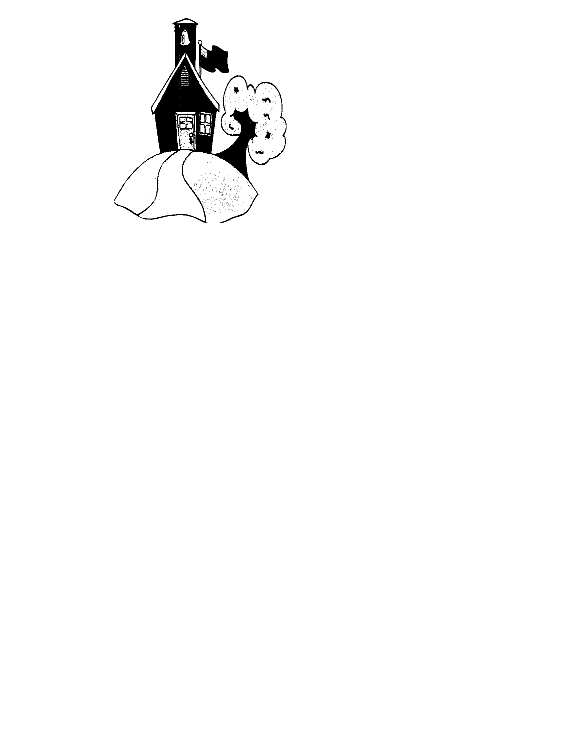
Student/ Parent Questionnaire

Child Name: _________________________________________

Parent’s Names: _________________________________________

Does your child have any known allergies or dietary restrictions? If so, please list
_________________________________________________________________________________________

When is your child’s birthday? ________________________________

Mommy: What kind of work do you do? _____________________________

What are your hobbies? __________________________________________

Daddy: What kind of work do you do? ______________________________

What are your hobbies? __________________________________________

What is your child’s favorite snack to eat? ________________________________________________

What are your child’s special interests? __________________________________________

Do you have a family member, friend, or neighbor who might be willing to share their profession or special interests with our class? ___________________________________________________________
Family E-Mail: __________________________________@____________________

Can we share your information with other parents in our class? __________________

Can we take photos of your child for family gifts? ____________ For our Facebook page? _____________

Does your child have siblings? If so, what are their names and ages? _____________________________

_______________________________________________________________________________________

Will anybody other than mom or dad be picking up from school? ____________________________________
If so, please list their names: _________________________________________________________________

